Manila Water Company
Customer NameDocument Title

FUNCTIONAL SPECIFICATION – WORKFLOW

DID_R2R_212 - Investment Ticket

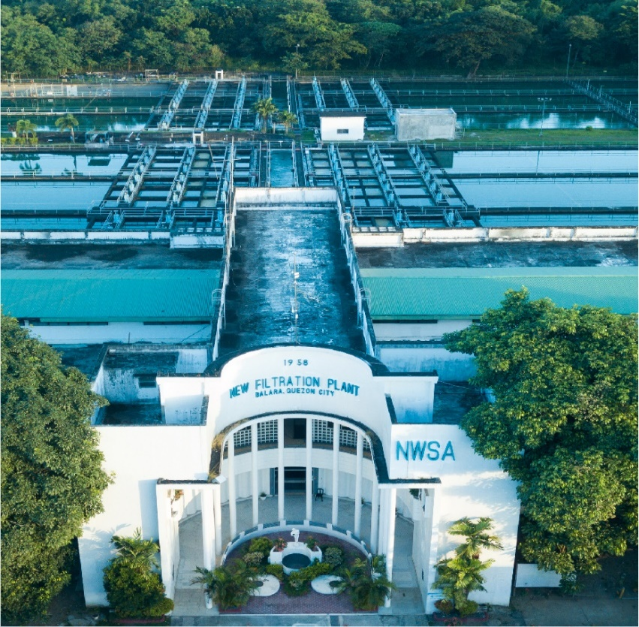




Contents
1 Document Organization 3
1.1 Document Log 3
1.2 Integration, Document Reference 3
2 Functional Description 4
2.1 Functional Flow Diagram of the Business Process 4
2.2 Security / Authorization Requirements 5
2.2.1 Definition 5
2.2.2 Defined Fields 5
2.2.3 Procedure 5
2.3 Dependencies / Constraints / Assumptions 5
3 Detailed Description 5
3.1 Workflow Realization 8
3.1.1 Transactions and Batch Programs that trigger the workflow 8
3.1.2 Start Conditions 8
3.2 Triggering Event 13
3.3 Business Object 13
3.4 Rules and Determination 13
3.4.1 Agent determination Rules 13
3.4.2 Delegation or Substitution Rules 13
3.4.3 Escalation Rules (Deadline Monitoring) 13
3.5 Work item Content, Notification Content, Notification recipients and attachments 13
3.6 Action upon Approval and Rejection 14
3.7 Reminder of Work 15
3.8 Conditions for terminating an ongoing approval 15
3.9 Error Handling 15
4 Performance 15
5 Open Issues in Functional Design 15
6 Business Test Conditions 15
7 Related Documentation 16

Document Organization
This section provides details about this document, previous version(s) of this document and the document(s) referred.

Document Log
Following table mentions the version changes and the processer(s):
Version | Status | Date | Version Created by (Name/E-Mail/Company) | Role | Comments
0.1 | Draft | December 9, 2024 | Ravi Yadav  ravi.yadav@sap.com | Author | Initial draft
0.2 | Ready for Review | December 10, 2024 | Mohanrangan  Mohanrangan.rangarajan@sap.com | Reviewer | Technical Review
0.3 | Reviewed with Comments | January 15, 2025 | MWC Treasury Team | Reviewer | Business Review required design change
0.4 | Reviewed with Comments | January 23, 2025 | MWC Treasury Team | Reviewer | WRICEF requirements gathering session with business
0.5 | Draft | January 24, 2025 | Ravi Yadav  ravi.yadav@sap.com | Author | Prepare FSD as per new design
0.6 | Ready for Review | January 28, 2025 | Mohanrangan  Mohanrangan.rangarajan@sap.com | Reviewer | Technical Review
0.7 | Reviewed with Comments | February 11, 2025 | MWC Product Owners  Value Delivery Leads | Reviewer | Business Review
1.0 | Final | February 13, 2025 | Ravi Yadav  ravi.yadav@sap.com | Author | Final Version

Integration, Document Reference
S. No. | Referred Document Name | Referred Document Version | Referred Document URL (Optional)
1 | MWC_SDD_TRM_03_Treasury and Risk Management | Final V2.0

The documents listed here are explicitly not part of this Functional Specification. They are not automatically accepted together with this Specification but may be subject to separate customer/SAP acceptance.

Functional Description
MWC prepares a Cash Dashboard Report in which the fund position of all the bank accounts is analyzed and, depending on the fund position, the investment or sweep decisions are taken by Liquidity Planning Team. Cash Dashboard Report is attached below: -
Cash Dashboard Report is prepared out of SAP system. Depending on the investment or sweep decisions as per Cash Dashboard Report, the Investment Ticket is prepared by Liquidity Planner and sent to the ‘Trader’ for further processes (i.e., Deal Slip – Placements).

This Investment Ticket has details like source of funds, amounts, tenor and others, so that ‘Trader’ can execute the necessary placements later. To prepare the Investment Ticket as per business specific layout, a custom object is required. Investment Ticket layout is attached below: -

This document captures the essential technical details like input screen, standard database tables and calculation logic necessary to prepare the Investment Ticket.

Functional Flow Diagram of the Business Process
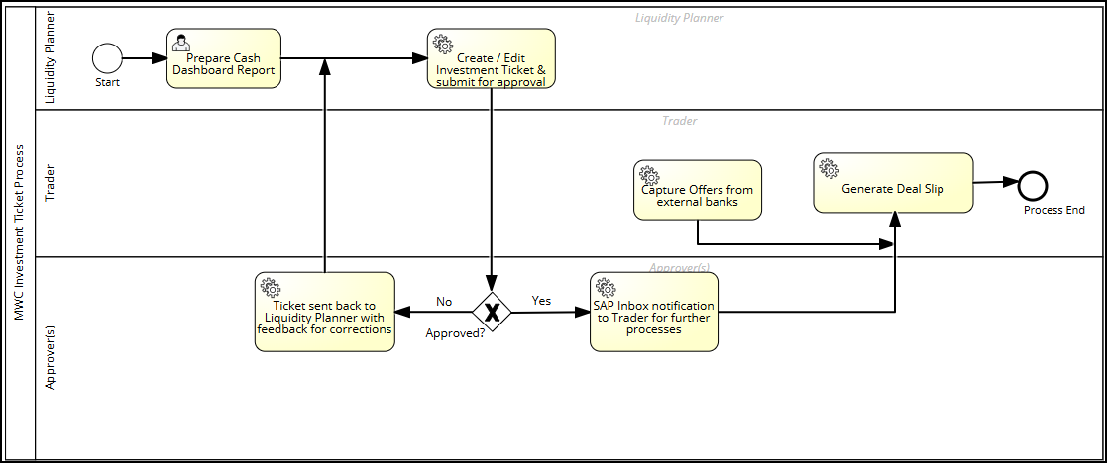

Security / Authorization Requirements
The custom transaction codes and Fiori tiles created for this enhancement to be assigned to the business role assigned to the corresponding business accountants. This business role will be updated here post conclusion of Roles & Authorization matrix.
- Fiori App: MWC Create Investment Ticket (ZTRM_INVST_TKT_CRT)
- Fiori App: MWC Review Investment Ticket (ZTRM_INVST_TKT_EDIT)

Separate authorization objects for Submit, Approve and Download buttons.

Definition
Standard / Custom Authorization Object:

Defined Fields
Not Applicable.

Procedure
Not Applicable.

Dependencies / Constraints / Assumptions
- Cash Dashboard Report of the Liquidity Planning team.
- Fixed deposits transactions with Payment Details assigned.
- Liquidity Planner to enter the Requirements in negative.
- House banks accounts set up.
- Electronic signatures cannot be printed on the output. For signatures, the Investment Ticket will be downloaded as PDF file, printed and signed manually.
No batch job is applicable here.

Detailed Description
Selection screen parameters (Screen 1): -
Table/  Structure Name | Field Name | Format | Default Value | Table Value/  Checkbox/  Radio Button/  Radio Button Group | Select Option or Parameter | Mandatory or Optional | Field Labels
T001  TRGC_TR_  ACC_CODE | Company Code | Alphanumeric | M001 | Table Value | Select Option | M (Single) | Company Code
TCURR | Currency | Char | PHP | Table Value | Select Option | M (Single) | Currency
 | Value Date | Date |  | Input | Select Option | M (Single) | Value Date
 | Ticket No. | Char |  | DISPLAY ONLY |  | M (Single) | Ticket No.
USR21 | Approver | Char |  | F4 Help |  | M (Single) | Approver
N/A | Notes | Char (200) |  | Input

- Ticket No. (IT-YYYYMMDD-Series No): -
  - IT-: Fixed
  - PHP : input Currency
  - YYYYMMDD-: From Value Date
  - Series No. (3 digits): Counter from SNRO object STVARV variable. Prefix with ZEROS, if required.

For the Company Code and Currency entered above, display the list of House Bank and Account IDs as below (Screen 2 layout): -

Source of Funds Section
Table / Structure Name | Field Name | Format | Default Value | Table Value/ Checkbox/ Radio Button | Mandatory or Optional
T012K | House Bank | Alphanumeric | N/A | Display | O
T012K | Account ID | Alphanumeric | N/A | Display | O
VTBFHA | Maturities | Numeric |  | DISPLAY | N/A
N/A | Fresh Funds | Numeric | ZERO | Input Field | O
N/A | Requirements | Numeric | ZERO | Input Field | O

- House Bank and Account ID: Pass Company Code and Currency into table T012K, and pick House Bank, Account ID and Account Number
- Maturities
  - Pass Company Code and Currency into table VTBFHA where Product Type = TD and Term End = Current Date, and pick Transaction and Term End
  - Pass Transaction into table VTBFHAPO, and pick Payment Amount in Payment Currency where Flow Type = 1120 PLUS
  - Pass Transaction into table VTBFHAPO, and pick Payment Amount in Payment Currency where Flow Type = 1200 and Due Date = Term End

Note: No validation of Fresh Funds and Requirements is required with respect to bank account G/L account balance.

Liquidity Disposition Section
Table / Structure Name | Field Name | Format | Default Value | Table Value/ Checkbox/ Radio Button
T012K | House Bank | Alphanumeric |  | F4 Help
T012K | Account ID | Alphanumeric |  | F4 Help
N/A | Amount | Numeric |  | Input Field
N/A | Maturity Date | Date |  | Input Field
N/A | Tenor | Numeric | Display Only | Auto-Calculated
N/A | Purpose | Char |  | Input Field
Add Another Tenor button

- Tenor: Maturity Date – Value Date

Note: The Total Amount (Maturities + Fresh Funds + Requirements) under Source of Funds and Total Amount under Liquidity Disposition sections MUST match before Liquidity Planner can generate the ticket.

Approver Section
Table / Structure Name | Field Name | Format | Default Value | Table Value/ Checkbox/ Radio Button
USR21 | Approver | Char |  | F4 Help
N/A | Notes | Char (200) |  | Input Field

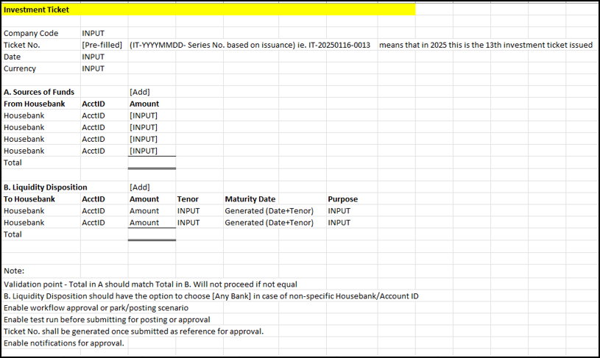
Based on input data, the program to generate the Investment Ticket as per layout attached under Heading 3.1.2.

Workflow Realization

Transactions and Batch Programs that trigger the workflow
Custom program - ZTRM_INVST_TKT
After entering relevant input parameters like Company Code, Currency, Fresh Funds and other, the Liquidity Planner will generate the Investment Ticket and will click on Submit button to trigger the custom workflow.

Start Conditions
Investment Ticket is generated as per layout below (Screen 3 - Output Layout) and Liquidity Planner clicks the Submit button to trigger the workflow: -
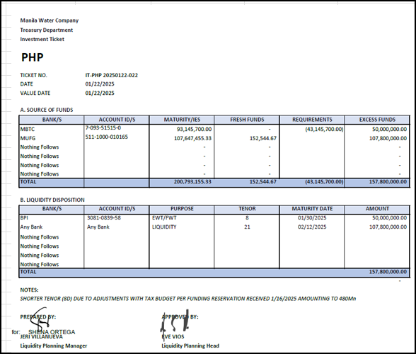
- Heading Section
  - Fixed Texts: Manila Water Company; Treasury Department; Investment Ticket
  - PHP: Input Currency
  - Ticket No.: Refer Heading 3 (Detailed Description)
  - Date: System Date
  - Value Date: Input Value Date

- Source of Funds Section
  - Bank(s): House Bank from input screen where either Fresh Funds or Requirements is NOT blank.
  - Account ID(s): Account Number fetched earlier while getting House Bank and Account ID from table T012K.
  - Maturities: From input screen for the respective House Bank and Account ID
  - Fresh Funds: From input screen for the respective House Bank and Account ID
  - Requirements: From input screen for the respective House Bank and Account ID. Display negative amount inside parenthesis.
  - Excess Funds: Maturities + Fresh Funds + Requirements
    - Assuming that the Liquidity Planner will enter the ‘Requirements’ as a negative amount.
  - TOTAL: Total of respective column amounts.

- Liquidity Disposition Section
  - Bank(s): House Bank from input screen (from Liquidity Disposition section).
    - If House Bank field is left BLANK, then print ‘Any Bank’.
  - Account IDs: Pass Account ID from input screen (from Liquidity Disposition section) into table T012K and pick Account Number.
    - If House Bank field is left BLANK, then print ‘Any Bank’.
  - Purpose: Purpose from input screen (from Liquidity Disposition section).
  - Tenor: Tenor from input screen (from Liquidity Disposition section).
  - Maturity Date: Maturity Date from input screen (from Liquidity Disposition section).
  - Amount: Amount from input screen (from Liquidity Disposition section).
  - TOTAL: Total of Amount column.

- Notes and Signatures
  - Notes: From input screen.
  - Prepared By & Approved By: Fixed texts
  - Prepared By – Name:
    - Pass system user into table USR21 and pick Person Number. Then, pass Person Number into table ADRP and pick Full Name
    - Pass system user into table IEMPLOYEEDETAILS for Language Key = EN and pick Identification Number
    - Pass Identification Number into table PA0001 and pick Name of Employee and Position
    - Pass Position into table T528T where Language = EN, and pick Short Text of Position
    - Display Name of Employee and Short Text of Position
  - Approved By – Name:
    - Pass approver entered on input screen into table IEMPLOYEEDETAILS and same as above
  - Date: System date (MM/DD/YYYY HH:MM:SS)
  - Designation
    - Display Short Text of Position fetched above for ‘Prepared By’ and ‘Approved By’
    - Liquidity Planning Manager: Maintain in STVARV variable (ZTRM_TKT_FD_LPM)
    - Liquidity Planning Head: Maintain in STVARV variable (ZTRM_TKT_FD_APR)

Review Investment Ticket
- Fiori App: MWC Review Investment Ticket (ZTRM_INVST_TKT_EDIT)
- Selection parameters screen
Table / Structure Name | Field Name | Format | Default Value | Table Value/ Checkbox/ Radio Button | Mandatory or Optional
T001 | Company Code | Alphanumeric | N/A | F4 Help | M
 | Investment Ticket Creation Dates | Date | Current Date | F4 Help | O (Range)
 | LP Manager | Alphanumeric | N/A | F4 Help | O
ZTRM_INVST_TKT | Investment Ticket No. | Alphanumeric | N/A | F4 Help | O

F4 Help of Investment Ticket No: Based on entered Company Code, Ticket Date and LP Manager, display applicable Investment Tickets with following details: -
- Investment Ticket No.
- Value Date
- LP Manager
Once a specific Investment Ticket is selected and pressed Execute, open the Investment Ticket in editable mode after fetching necessary details from the custom tables.
Once the Liquidity Planner clicks the Submit button, update the details in the custom table(s) and send Investment Ticket for approval purposes via custom workflow.

Further processes: -
- Submit, Approve and Download and Print buttons to be provided on the output screen.
  - Separate authorization objects for these buttons to control the authorizations.
    - Auth. Object 1: Submit and Download
    - Auth. Object 2: Approve and Download
- Once the Liquidity Planner clicks on Submit button, workflow notification to be sent to the approver in Outlook mail SAP Inbox (SBWP). And simultaneously store the input parameters in the custom tables provided below.
- Once an approver approves,
  - Send mail SBWP notification to the Trader
  - Refer Section 3.5 for the message body
- If an approver rejects,
  - Workflow item is sent back (SBWP) to the creator (i.e., Liquidity Planner) for modifications as per feedback.

Structure of custom table ZTRM_INVST_TKT_HDR: -
Field Name | Format
Company Code | Alphanumeric (4)
Currency | Char (100)
Value Date | Date
Approver | Char (10)
Notes | Char (200)
Ticket No | Alphanumeric (20)

Structure of custom table ZTRM_INVST_TKT_SRC: -
Field Name | Format
Ticket No | Alphanumeric (20)
House Bank | Alphanumeric (5)
Account ID | Alphanumeric (5)
Maturities | Numeric
Fresh Funds | Numeric
Requirements | Numeric

Structure of custom table ZTRM_INVST_TKT_LQY: -
Field Name | Format
Ticket No | Alphanumeric (20)
House Bank | Alphanumeric (5)
Account ID | Alphanumeric (5)
Amount | Numeric
Maturity Date | Date
Purpose | Char (10)

Standard Workflow Template

Technical Details – If not know please check with Development Lead
Workflow Template Number | N/A
Abbreviation | N/A
Name | N/A

Triggering Event
Refer Heading 3.1.1

Business Object
Entirely custom Business Object is required.

Rules and Determination

Agent determination Rules
Liquidity Planner to input the Approver on the input screen.

Delegation or Substitution Rules
In case substitute is maintained, the workflow item to be sent to both Approver as well as to the Substitute. Substitute to be maintained by respective approvers in the My Inbox Fiori app for the leave period.
- Select REP_NAME from table HRUS_D2 where US_NAME = Approver and System Date is between Start Date (BEGDA) and End Date (ENDDA)

Escalation Rules (Deadline Monitoring)
Not Applicable.

Work item Content, Notification Content, Notification recipients and attachments
This is to be sent as Outlook mail SAP Inbox (SBWP) notification, and no Outlook mail or attachment is required.

Subject: Investment Ticket <Ticket No> Approval

Notification to Approver (after Submit button)
Message Body:
Dear <Approver>,

Investment Ticket <Ticket No.> has been sent for your approval. Please review.

Regards,
<Creator>

Notification to Trader once Approved
Message Body:
Dear <Trader>,

This is to inform you that Investment Ticket <Ticket No.> has been approved.

Regards,
<Approver>

Notification to Creator (i.e., Liquidity Planner) once Rejected
Message Body:
Dear <Creator>,

Investment Ticket <Ticket No.> has been sent back. Please re-submit after necessary corrections.

Regards,
<Approver>

- For <Approver> & <Creator>
  - Pass user id in the table USR21 and pick Person Number
  - Pass Person Number in table ADRP and pick Full Name
  - Pass user id into table IEMPLOYEEDETAILS for Language Key = EN and pick Identification Number
  - Pass Identification Number into table PA0001 and pick Name of Employee and Position

- For <Trader>
  - Fetch users assigned to a specific role (say ZS4T:TRM:TRM_FRONT_OFFICE_TRANS).
  - Pass role into table AGR_USERS - AGR_NAME and pick User (UNAME) where End Date (TO_DAT) > System Date

Action upon Approval and Rejection
Upon Approval,
- Mail SAP inbox notification (SBWP) to the Trader
- Workflow is complete.

Upon Rejection,
- Workflow is directed back to the creator (start from beginning without generating a new instance)
- Creator to edit the Investment Ticket and Submit it again.

Reminder of Work
Not Applicable.

Conditions for terminating an ongoing approval
Not Applicable.

Error Handling
Not applicable as no standard transaction is being executed automatically upon Submit or Approval. This workflow is mainly used for notification and approval purposes.

Performance
All the background steps of the workflow should be having errors as output parameters for analysis purposes in case of any error.

Open Issues in Functional Design
- Fetch Trader based on a business role. We need to align on the specific role after Roles & Authorization Matrix finalization.

Business Test Conditions

Scenario # | Input Selection Criteria | Expected Result
1 | Execute Fiori App - MWC Create Investment Ticket and provide input parameters. | Investment Ticket is generated and submitted for approval.
2 | Approver receives the SAP Inbox notification and approves the Investment Ticket. | Mail SAP Inbox notification to Trader.  Workflow is completed.
3 | Execute Fiori App - MWC Review Investment Ticket and provide input parameters. | Investment Ticket is edited and submitted for approval again.
4 | Approver receives the SAP Inbox notification and rejects the Investment Ticket. | Mail SAP Inbox notification to the creator.  Workflow item sent back to the creator.

Related Documentation
Not Applicable.

